**Discrete age-structured mathematical model for application of measles vaccination strategies**

**Ziyabukwa Mthi**

24863831

A Research Proposal for the Biomathematics Honours Project

Supervisor: Dr L. Bolton

Co-supervisor: Mr J. Bingham



Department of Mathematical Sciences

Stellenbosch University

South Africa

15 August 2022

Contents

Abstract 3

Introduction 4

Research question 6

Aim of the research 6

Main objective of the research 6

Research objectives 6

Study benefits 7

Literature review 8

Measles 8

Mathematical modelling of infectious diseases 9

Kermack and McKendrick model 10

Measles transmission models 11

Models of Measles 11

Measles vaccination 12

Model on Vaccination Strategy for Measles 13

Age distribution 14

Model involving age structed 14

Methods 16

Mathematical Model 16

Application of measles vaccination methods 17

Measles vaccination model 18

Parameter estimation 20

Immune profile analysis 22

Effect of improving vaccination coverage and efficacy of measles 22

Code design 23

Limitations 23

Numerical Analysis 24

Immune profile analysis 24

Effect of improving vaccination coverage of measles 28

Conclusion 31

References 32

# Abstract

The World Health Organization aims to eliminate measles infection by enforcing scales of measles vaccine. Measles is a viral infection and is highly contagious. Infants are most susceptible to measles infection. The most effective public health strategy against infectious diseases that can be prevented by vaccination, like measles, is a vaccine. Measles vaccine is administered as two doses of Measles-Mumps-Rubella (MMR) vaccination per child. The important factor that contributes to population variability and has a considerable impact on the timing and outcomes of the spread and transmission of infectious diseases is age distribution. We investigate a discrete age-structured SEIR model to analyse measles outbreaks that occurred in South Africa. We further evaluate and discuss the effectiveness of various vaccination strategies for control of measles epidemics. We use our model to distinguish between different scenarios of vaccine coverage. Our model's prediction demonstrates the positive benefits of the present vaccination campaign in South Africa by indicating that annual measles occurrences will continue to be below the WHO eradication goal of 5 cases per million people. According to the immunological profile analysis, the low effective vaccination coverage $(θ_{1})$ among infants aged 6 to 12 months, which will only reach 50% by the end of 2024, is a contributing factor. Figure 4 shows that this age group had the highest incidence of measles during 2017 and 2018. The vaccine coverage rate can be increased by either increasing effective coverage $(θ_{1}σ_{1})$ or increasing vaccine coverage.

# Introduction

Measles is a contagious and viral infection caused by the virus for infants [1], however it can be prevented with a vaccine [2]. The respiratory system becomes infected by the virus, which subsequently spreads to the rest of the body. Infants are most susceptible to measles infections, which can cause lifelong problems like severe brain damage, blindness, or hearing loss as well as complications including pneumonia and encephalitis [3]. Transmission occur during direct contact with infectious droplets or airborne spread caused by an infected person's breathing, coughing, or sneezing [4]. After exposure, symptoms of measles don't begin to develop for 10 to 14 days. Clinically, the incubation period from exposure to early symptom onset of disease averages 10 - 12 days from exposure to the virus and it last about 7 – 10 days [5]. It is estimated that 90% of exposed susceptible individuals are exposed to measles [6]. The majority of healthy infants who contract the measles virus recover fully, and there is a low fatality rate. About 30% of measles cases in children under the age of five can result in serious complications [7]. However, despite successful immunization, which led to a decline in measles-related fatalities worldwide between 2000 and 2011 [8]. More than 140,000 individuals died from measles in 2018 alone. 52,600 of these deaths, according to the WHO, happened in Africa [9].

Prior to the measles vaccine was created in the 1960s, the disease was a leading risk factor for mortality worldwide [10]. Since the creation of safe and effective vaccinations in 1963, infant measles infections have declined. It is estimated each year, 2.6 million individuals worldwide are afflicted and killed by measles. [11]. Measles remains the most cause of mortality among children younger than the age of five, despite the availability of vaccinations [7]. In places like Liberia, Madagascar, and Somalia, where vaccination rates are poor, measles outbreaks continue to occur [12]. According to the WHO, global effort to increase vaccination coverage lowered deaths by 73% in 2018. The Measles Eradication Initiative was updated by WHO in 2012 with the intention of eliminating measles in at least five of the world's six regions by 2020 [13]. The World Health Organization defines measles eradication as the absence of indigenous measles cases in a given area for at least 12 months while elevated monitoring systems are present. In addition, the WHO mandates a 95% nationwide measles vaccination rate across all districts, with two doses administered to each kid. At least 80% of districts must investigate at least one suspicious case within a year, and there must be at least 2 non-measles cases per 100,000 inhabitants nationwide. [14].

A vaccine is the most effective public health intervention for combatting vaccine-preventable infectious diseases such as measles [15]. Between 2000 and 2017, measles mortality decreased by 80% as a result of vaccination, and as of 2017, 85% of children globally have received their first dose [16]. The measles vaccine is commonly administered to two doses of the Measles-Mumps-Rubella (MMR) vaccination and it is scheduled for two doses each child. Infants frequently receive their first dose of the measles vaccine at 6 months, followed by second dose at 12 months [6]. World Health Organization (WHO) strongly encouraged the usage of MMR vaccines to get rid of the measles virus inside the nations by enforcing large-scale vaccination programs [13].

Age distribution is the significant element that makes contributions to the heterogeneity of populations, with a substantial impact on the timing and effects on the spread and transmission of infectious diseases [17]. Most crucially, there is a considerable degree of non-uniformity in transmission rates due to the patterns and frequency of individual encounters, which can range dramatically between age groups [18]. Age-related differences in immune capacity to infectious disease are also possible. These changes may have an impact on age-specific fatality and infection recovery rates [17].

This study will focus on the transmission of measles in a host population with an age structure. We will examine a mathematical model with discrete age structure and the use of measles vaccination strategies. The effectiveness and vaccination coverage vary depending on the age group. The first dose of the measles vaccination is recommended for infants 6 months of age, and the second dose is recommended for infants 12 months of age. Both doses of measles vaccine are intended to lower the incidence rate [18].

To conduct this study, we will construct a discrete age-structured SEIR model to analyse measles outbreaks that occurred in South Africa. We further evaluate and discuss the effectiveness of various vaccination strategies for control of measles epidemics. The model is used to answer our desired research question. We should be able to use our model to distinguish between different scenarios of efficacy and vaccine coverage.

## Research question

How different vaccination strategies would influence the transmission of measles in population?

### Aim of the research

The proposed research question is investigating the Measles SEIR epidemic model to comprehend the dynamics of infection spread in an age-structured host population, an epidemic model with different ages is required.

## Main objective of the research

The main objective of the research is to formulate a mathematical model for measles vaccination strategies and transmission dynamics.

### Research objectives

* To explore transmission dynamics of measles in age-structured host population.
* To study the vaccination strategies for measles with discrete age structure.
* To analyse South African measles data and evaluate the effectiveness of various vaccination strategies for measles epidemic control.
* To compare the outcomes of the effect various measles vaccination strategies.
* To modify an age-structure model for measles vaccination on measles incidence.

## Study benefits

The efficiency of vaccination strategies and measles elimination targets will be shown by the discrete age structure epidemic model when used in conjunction with the measles vaccination strategy for future predictions. The modified two age groups that includes the current measles vaccination in the measles vaccination programs will help with the analysis of the immunological profile of the population and in each age group to establish the base and make predictions.

The model will then demonstrate that two doses of vaccination given to each person has an effect that is more or equivalent to 95% vaccine coverage. The study will also demonstrate the effects of boosting the effectiveness of two doses in lowering measles incidence at a modest vaccination coverage.

# Literature review

## Measles

The measles virus is the cause of this extremely contagious disease that is caused by Morbidly virus. Measles patients present with a rash and a fever. Small, flat, red patches that first form on the head or face before spreading down the body are the rash's outward manifestation. The rash is neither unpleasant or itchy, nor does it produce blisters. Cough, conjunctivitis (red eyes), and coryza are further symptoms (running nose). Measles can result in mortality, dehydration, encephalitis, middle ear infections, blindness, and other complications. The red rash that appears a few days after the fever starts and the high fever that manifests after an incubation period of 9–10 days are the main signs of the disease. Measles may also cause ocular symptoms in addition to particular generic symptoms. It is a highly (approximately 95%) contagious disease that mostly affects children but can potentially infect adults if they have not had the recommended immunizations.

A Persian physician provided the first descriptions of the measles disease in the ninth century. Francis Home, a Scottish physician, discovered in 1757 that the bacterium that causes measles is detected in patient blood. In 1912, measles was declared a globally reportable transmission of infection in the United States, requiring all cases to be reported by medical personnel and laboratories. 6,000 deaths linked to the measles were reported annually on average over the first ten years of reporting. The majority of children got the measles by the time they were 15 years old prior to the 1963 development of a vaccine.

Measles infections can occur wherever in South Africa and are not restricted to certain risk groups or geographic locations. Communities and institutions like daycare facilities and crèches may contain cases. When visiting regions where measles cases have been documented or where measles is a very common disease, adult travelers who were not immunized as children run the risk of contracting the disease. An outbreak is when there are several measles cases in a given location within a short period of time (three or more cases in a health district within four weeks), at which point public health efforts are needed to stop the disease's spread. In 2009, there was a significant measles outbreak in South Africa, with over 18,000 cases being confirmed.

## Mathematical modelling of infectious diseases

Mathematical modelling of infectious disease started in 1760 whilst Daniel Bernoulli adopted epidemic models to determine whether or not inoculation of healthy individuals with smallpox changed into a powerful approach of preventing the unfold of the disease (Bernoulli 1760). Bernoulli changed into the first to represent the proportion of healthy individuals which might be at risk of an infectious disease in phrases of the force of infection and the lifestyles expectancy. Deterministic epidemic modelling started to be normally used within the 20th century, with mathematicians together with Ross, Kermack and McKendrick contributing significantly to this discipline. Prior to the 20th century, an essential result was determined by Hamer who establish that the progression of an epidemic is dependent upon the quantity of susceptible individual in a population and the rate at which infectious individual and susceptible individuals come into contact with each other (Hamer 1906). Early in the 20th century, Ross developed fundamental deterministic epidemic model where in differential equations are used to explain modifications within the range of susceptible and infectious hosts, in addition to the full wide variety of hosts within the population, through the time (Ross 1916). Deterministic models offer affordable approximations to the adjustments in the number of susceptible and infectious hosts over the time while the numbers of each type of host are large. This basic model can be actually extended to bear in mind other functions of the sickness under observe.

### Kermack and McKendrick model

In 1927, Kermack and McKendrick prolonged the simple model of Ross to attempt to constitute the adjustments in the quantity of infected people located in epidemics together with the plague and cholera []. The Kermack and McKendrick model keeps the fundamental structure of the model with the aid of Ross, with non-linear ordinary differential equations used to describe the rate of exchange of the quantity. As an illustration, the Susceptible-Infected-Susceptible model is used to describe many respiratory infections, such as influenza, spread []. The measles model is described by Susceptible-Infected-Recovered [], many infectious diseases, including tuberculosis, are described using the susceptible-exposed-infected-recovered model [], and many vector-host models, including malaria and dengue disease, are described using the susceptible-exposed-infected-recovered in the host and susceptible-infected in the vector (SIR-SI) model. []. The Susceptible-Infected-Susceptible (SIS) model is typically used to simulate a disease in which recipients undergo a small period of temporary immunity following infection before returning to their susceptible class. The Susceptible-Infected-Recovered (SIR) model simulates a disease in which individuals have either long-lasting temporary immunity or permanent immunity. To represent diseases with long incubation and immunity durations, the Susceptible-Exposed-Infected-Recovered (SEIR) model is frequently used. To learn the distinctions between SI, SIR, and SEIR, please refer to Figures 1, 2, and 3.

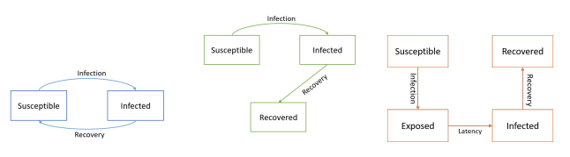

Figure 1: SIS model Figure 2: SIR model Figure 3: SEIR model

According to Figures above show how the recovered compartment will take on the SIR and SEIR models population, but the population of the SIS model will not be absorbed into any compartment.

In order to illustrate incorporating the population into the recovered compartment, we now analyze a specific instance of the SIR model in measles.

Since individuals who have recovered from the disease have a lifelong immunity to the measles, measles may be modeled using the Susceptible-Infected-Recovered model technique. This model serves as the starting point for numerous measles models. Birth, death, infection, and recovery are all included in this model. The given model is as follows:

$$\frac{dS}{dt}=H- βSI- μS ,$$

$$\frac{dI}{dt}= βSI- γI- μI$$

$$\frac{dR}{dt}= γI- μR$$

$S+ I + R = N$ where $N$ is the total number of people, $H$ the birth rate, $β$ the transmission rate, $μ$ the mortality rate, and $γ$ the infection recovery rate.

## Measles transmission models

Several models for the transmission of the measles will be addressed in this section. In general, the fundamental SIR model was expanded to account for the significant challenges that they sought to comprehend.

### Models of Measles

The SIR model has been modified to account for measles with a latent period []. By applying the following model, Bakare in [] depicted the transmission of measles in 2012.

$$\frac{dS}{dt}= λ- \frac{βSI}{N}-μS$$

$$\frac{dE}{dt}= \frac{βSI}{N}-(σ+μ)E$$

$$\frac{dI}{dt}=σE-\left(γ+μ\right)I$$

$$\frac{dR}{dt}=γI- μR$$

The model represents a homogeneous population. Measles transmit when a susceptible $(S)$ individual has a sufficient contact with infected individual $(I)$. When a person is exposed, they are considered to be in the exposed class (E), which means that even though they are diseased, they cannot spread the disease. The individual joins the infectious population $(I)$ when the latent phase is over, where they might spread diseases. The individuals then join the recovered population, which is made up of those with enduring immunity to the disease, and the numbers of people in each group may fluctuate due to natural mortality.

A. A. Momoh created a model comparable to system that was created by Barake in 2013 by taking into account measles testing and treatment for people who have been exposed. In order to change model (3), as a result of testing and measles treatment, a direct transition from exposed to recovered was added. Through numerical analysis and simulations, the impact of exposed individuals on the dynamics of measles transmission is investigated using this model.

## Measles vaccination

Vaccination is the strongest protection against measles. Before the introduction of a successful vaccine in 1963, measles infection was almost endemic in children and was considered to be the cause of 2.6 million annual fatalities. As part of the Expanded Programme on Immunization (EPI), single-dose measles vaccination was introduced to South Africa in 1975. After that, in 1995, a two-dose plan was implemented, with additional immunization drives taking place 3–4 years, on average. The two-dose measles vaccination model was modified to 6 and 12 months in 2016. The disease's high morbidity and mortality rates in early infancy are intended to be prevented by giving the first dose at 6 months of age.

It is recommended that the population immunization rate be at least 95% to minimize measles outbreaks. Only 85% of children worldwide, according to estimates from the World Health Organization (WHO), had received the first dose of the measles vaccine by the time they turned one and 64% had received the second dose by that time. South Africa has experienced numerous measles outbreaks throughout the years; There were 1 676 laboratory-confirmed case-patients from 2003 to 2005, and there were over 18 000 from 2009 to 2011.

### Model on Vaccination Strategy for Measles

The vaccination has been added to the SEIR model for measles [21]. Comparable to the set of equations (3), O. M. Tessa created a model in 2006 that takes vaccinated newborns into account as follows:

$$\frac{dS}{dt}= b\left(1-p\right)N- \frac{βSI}{N}-μS$$

$$\frac{dE}{dt}= \frac{βSI}{N}-(σ+μ)E$$

$$\frac{dI}{dt}=σE-\left(γ+μ+δ\right)I$$

$$\frac{dR}{dt}=bpN+ γI- μR$$

where $p$ represents the percentage of newborns that received their vaccinations effectively.

Stephen updated the SEIR model in 2015 by including compartments for vaccinated individuals, two doses of vaccine, and vaccinated children and immigrants. People who have had two doses of the vaccine will have lifetime protection, however those who have only received one dose are still susceptible to measles infection. The model is examined by the authors using dimensionless transformation.

Reduced exposure to measles-infected people should be a top aim to reduce the possibility of an epidemic. Mass vaccination campaigns should be encouraged in order to build up the population's resistance to the disease and stop it from spreading to developing countries. The prevention of disease spread through early treatment of affected individuals [].

They offered a mathematical model of the dynamics of the measles infection with vaccinations by taking into account the total number of recovered populations from either spontaneous recovery or recovery brought on by vaccination. There is a susceptible person who has a brief incubation time, allowing them to join the infected group as soon as they become infected. Even if they have received the vaccine, people who have been exposed to or infected with the measles can develop a lifetime immunity. Immunization can, according to numerical simulations, lower the proportion of populations that are exposed to and contagious. Vaccine can prevent the transmission of measles infection.

## Age distribution

Both discrete and continuous methods have been used to explore the age-structure of epidemic models. In this study, both partial differential equation (PDE) models with continuous age structure and ordinary differential equation (ODE) models with discrete age groups are used. In 1906, Hamer developed and analyzed a discrete time model in an effort to understand why measles outbreaks occur repeatedly. His model might have been the first to make the assumption that the incidence (number of new cases per unit of time) was a function of the sum of the densities of the susceptible people and infectious agents [1].

Much of the recent theoretical progress for PDE models has been inspired by the models' well-posedness and the characteristics of the semigroups they are connected with. ODE models present a mathematical analytical problem because of the great complexity and enormous scale of the ODE system, despite the fact that the mathematical framework is rather straightforward due to the finite dimensionality of the phase space. It is quite difficult to demonstrate the dynamics of age-structured modeling techniques using either technique.

Epidemic models on transmission networks can be conceptualized as linked nonlinear differential equation systems with discrete age patterns. Each age group in this model can be thought of as a node, and inter-group transmissions and aging create the connections between nodes. Models with discrete age groups can be created using the graph-theoretic technique outlined in [], which builds Lyapunov functions for coupled systems on networks.

### Model involving age structed

The SIRS model for age structure incorporating immunization was discussed by David W. Tudor. After that, the measles virus is modeled using this model and a zero-immunity loss rate. The model's application to measles suggests that the vaccination rates required to bring the incidence down to Nearly zero might not equal what homogeneous mixing had previously indicated [].

A comparable age structure model to David W. Tudor's was explored by Zhou et al. in 2019, however they additionally considered age transfers, disease deaths, and births. The author uses the following model in []:

$$\frac{dS_{k}}{dt}= Λ_{k}+α_{k-1}S_{k-1}- \sum_{j=1}^{n}{β_{kj}S_{k}I_{j}}-d_{k}S_{k}-α_{k}S_{k}$$

$$\frac{dI_{k}}{dt}= α_{k-1}I_{k-1}+ \sum_{j=1}^{n}{β_{kj}S_{k}I_{j}}-\left(d_{k}+μ_{k}+α_{k}+γ_{k}\right)I_{k}, k= 1,2,….., n$$

$$\frac{dR_{k}}{dt}= α_{k-1}R_{k-1}+γ_{k}I_{k}- d_{k}R_{k}-α_{k}R_{k}$$

They investigated numerous measles vaccination options, such as improving the coverage of the first and second doses and improving the efficacy of the first dose vaccine, using their model and data from India.

Measles is a highly contagious disease that can spread quickly to susceptible populations through contact or from any source that can spread. We looked at other models that previous writers have created in order to understand a number of key components of the measles management plan, including vaccination, treatment, age structure, coexistence with other diseases, etc. These simulations demonstrate that the most effective strategy for containing the measles outbreak is a 2-dose vaccination program.

# Methods

## Mathematical Model

In this section, a mathematical model to describe the dynamics of measles transmission is developed. It is deterministic and compartmental. The host population is assumed to be homogeneous mixed for both age groups and reflecting to increasing dynamics such as birth [29]. Natural death and birth rates per capita are both consistent over time [30]. Direct contact with an infectious person can result in infection [31]. Infants who receive the both measles vaccine dose consecutively develop a permanent immunity to the disease.

We assume that infants that are unvaccinated at 6 to 12 months enters directly in the susceptible class 1 $(S_{1})$, while vaccinated infants with first dose enters directly into recovery class 1 ${(R}_{1})$. We assume that children that are vaccinated with second dose at 12 to 60 months enters directly into recovery class 2 ${(R}_{2})$, while unvaccinated enters the susceptible class 2 ${(S}_{2})$. During the incubation period, the susceptible class $(S_{k})$ joins the exposed class $(E_{k})$ of infants who are affected but not yet infectious, when sufficient contact between a susceptible and an infective result in transmission. The individual joins the class $I$ of infectives after the incubation period, which makes them infectious in that they can transfer measles infection. The children enter the recovered class $(R_{k})$ when the infectious period ends if they have gained an immunity to infection, otherwise passes away. These are the classical assumptions based on SEIR model. This model assumes that an infant will be protected from measles by a successful vaccination.

In this section, we construct a vaccination model with two age structure to evaluate the vaccination strategies for two dose of measles vaccination [21,22], first dose (6 - 12 months), and second dose (12 – 60 months).

$$θ_{2}σ_{2}α_{1}$$

$$Λ(θ_{1}σ_{1})$$

$$(1-θ_{2}σ_{2})α_{1}$$

$$Λ(1-θ_{1}σ_{1})$$

$$d_{1}$$

$$d_{1}$$

$$β_{1}c_{1j}S_{1}I_{J}$$

$$β_{2}c_{2j}S_{2}I_{j}$$

$$(d_{1}+μ_{1})$$

$$α_{1}$$

$$α_{1}$$

$$α_{1}$$

$$γ_{2}$$

$$ε_{2}$$

$$γ_{1}$$

$$ε_{1}$$

$$R_{2}$$

$$I_{2}$$

$$E_{2}$$

$$S_{2}$$

$$R_{1}$$

$$I_{1}$$

$$E_{1}$$

$$S_{1}$$

$$d_{1}$$

$$d_{2}$$

$$α_{2}$$

$$α_{2}$$

$$d_{2}$$

$$d_{2}$$

$$α_{2}$$

$$α_{2}$$

$$(d_{2}+μ_{2})$$

Figure 1: Model for a measles vaccination model with two vaccination doses.

## Application of measles vaccination methods

## 

Measles is a disease that can be prevented with a vaccine [7]. It typically takes two doses to fully protect against measles, which is included in the Measles, Mumps, and Rubella (MMR) vaccine. Infants generally receive their first dose of the measles vaccine at 6 months of age, the second dose is administered at 12 months [8]. The efficacy of two doses of the measles vaccine ranges from 93% to 99% [9]. In South Africa, vaccine coverage requires a maximum of 95% or higher to be sustained with both doses administered per person [10].

## Measles vaccination model

The model is dividing a host population of a constant size into susceptible (infants who may be infected), exposed (infants who are exposed to the infection), infected (infants who are infected and can transfer infection) and recovered (infants who received the second dose of vaccine and those who have enduring infection-acquired immunity) classes. Compartments with labels the epidemiology classes include $S, E, I,$ and $R$.

For the $k^{th}$ age group, the influx susceptible individuals are specified by the rate of $Λ_{k}$. $β_{kj}$ is the transmission coefficient between $S_{k}$ and $I_{j}$. Exposed individuals move to the infectious class at a rate of an age group of $ε_{k}$. Infectious individuals move to the recovered compartment at a rate of an age group of $γ_{k}$. Individuals are aging at a rate $α_{k}$. Natural mortality rate of an age group is represented by $d_{k}$, while case mortality of an age group is represented by a rate of $μ_{k}$.

It is assumed that proportion of infants who received the first dose $θ_{1}σ_{1}$ of the vaccination joined the class of recovered infants $R_{1}$ whilst infants who received second dose $θ_{2}σ_{2}$ of vaccine join the recovered class $R_{2}$. The compliments $1-θ_{1}σ_{1}$ and $1-θ_{2}σ_{2}$ joins the susceptible classes of $S_{1}$ and $S_{2}$ respectively. Since the disease is severe, those who contract it may pass away from the disease or naturally pass away.

* Age-group 1 (6 – 12 months olds)
* Age-group 2 (12 – 60 months olds)

We subdivide the host population into two age groups, taking into consideration variations in vaccination programs strategies and interaction patterns according to age. The model is described by the following system of differential equations.

Differential equations for age group 1:

$$\frac{dS_{1}}{dt}= Λ\left(1-θ_{1}σ_{1}\right)-β_{1}c_{1j}S_{1}I_{J}- \left(1-θ_{2}σ_{2}\right)α_{1}S_{1}-d_{1}S_{1}$$

$$\frac{dE_{1}}{dt}= β_{1}c_{1j}S_{1}I_{J}-(α_{1}+ d_{1}+ ε_{1})E_{1}$$

$$\frac{dI_{1}}{dt}= ε_{1}E_{1}-\left(α_{1}+ γ_{1}\right)I_{1}-(d_{1}+ μ_{1})I_{1}$$

$$\frac{dR_{1}}{dt}= γ_{1}I_{1}+Λθ_{1}σ_{1}-(d_{1}+ α_{1})R_{1}$$

Differential equations for age group 2:

$$\frac{dS_{2}}{dt}=\left(1-θ_{2}σ_{2}\right)α_{1}S_{1}- β_{2}c_{2j}S_{2}I_{J}-(d_{2}+ α_{2})S_{2}$$

$$\frac{dE_{2}}{dt}= β_{2}c_{2j}S_{2}I_{J}+α_{1}E_{1}-( d_{2}+α_{2}+ ε_{2})E_{2}$$

$$\frac{dI_{2}}{dt}= ε_{2}E_{2}+α_{1}I_{1}-γ_{2}I_{2}-\left(d_{2}+ μ_{2}\right)I_{2}-α_{2}I_{2}$$

$$\frac{dR_{2}}{dt}= γ_{2}I_{2}+θ_{2}σ_{2}α_{1}S_{1}- α_{2}R_{2}-d_{2}R_{2}+ α_{1}R_{1}$$

## Parameter estimation

The model parameters are shown in Table 1 along with their description and units. Specifically, $θ_{1}$ and $θ_{2}$ are the vaccination rates of MMR1 and MMR2, respectively, $σ_{1}$ and $σ_{2}$ are the efficacy of MMR1 and MMR2, respectively, and $θ_{1}σ_{1}$ and $θ_{2}σ_{2}$ are the effective coverage of MMR1 and MMR2, respectively.

To incorporate vaccination, assume a proportion, $θ_{1}σ_{1}$, of 6-month-old into the population are vaccinated (and thus immune to infection). Vaccinated people bypass the susceptible class and go directly to the recovered class, while unvaccinated people go to the susceptible class as before. If $θ_{1}σ_{1}$ is the proportion vaccinated, then $1-θ_{1}σ_{1}$ is the proportion left unvaccinated.

The transmission coefficient $β_{kj}$ between $S_{k}$ and $I_{j}$ has two parts $β_{kj}= β_{k}c_{kj}$, the mean of interactions between infants in age groups k and k is represented by the variable $c_{kj}$. The likelihood of transmission for a typical encounter from susceptible infants in age group k and an infectious infant is $S_{k}$, and $c_{kj}$. Be aware that the age difference between $c_{kj}$ and $c_{jk}$ may prevent the interaction matrix $(c_{jj})$ from being symmetrical. The aging rate of infants of age group 1 (6 – 12 months) is calculated and resulted to 0.038, while the aging rate of children of age group 2 (12 – 60) is 0.0038.

Using population statistics to determine the age distributions among the two age groups, we computed the contact matrix $(c_{ij})$ for the population of South Africa using the method described in [21]. Table 2 displays the outcome.

As indicated in Table 1, several model parameters and the starting values of state variables are estimated. Other parameter values are estimate by fitting the model outcomes to measles data using the nonlinear least squares method [11].

|  |  |  |  |  |
| --- | --- | --- | --- | --- |
| Parameters | Values/Range | Unit | Description | Ref |
| $$Λ_{k}$$ | 650 |  | Influx of susceptible | fitting |
| $$d_{k}$$ | 0.0241 | $${week}^{-1}$$ | Mortality rate of age group k | [20] |
| $$γ_{1}$$ | 0.024368 | $${week}^{-1}$$ | Recovery rate for age group k | fitting |
| $$ε_{1}$$ | 0.72 | $${week}^{-1}$$ | Exposed rate of age group | [13] |
| $$μ_{k}$$ | 0.2 | $${week}^{-1}$$ | Induced mortality rate of age group k | fitting |
| $$θ_{1}$$ | 0.717 |  | Vaccination coverage of first dose | [10] |
| $$θ_{2}$$ | 0.764 |  | Vaccination coverage of second dose | [10] |
| $$σ_{k}$$ | 0.95 |  | Efficacy of measles vaccine | [9] |
| $$β_{1}$$ | 0.1679 |  | Likelihood of transmission rate for age group 1 | fitting |
| $$β_{2}$$ | 0.5154 |  | Likelihood of transmission rate for age group 2 | fitting |

Table 1: Model parameters and estimated values.

|  |  |  |
| --- | --- | --- |
|  | 6 – 12 months | 12 – 60 months |
| 6 – 12 months | 8 | 2 |
| 12 – 60 months | 2 | 12 |

Table 2: Contact matrix for model

## Immune profile analysis

The purpose of immune profile analysis for the population and two age group is to evaluate sustained effort of measles vaccination strategies, particularly after introduction of second dose of vaccination. We will examine the percentage of population that has received vaccination and the percentage that has immunity from prior infection. This will demonstrate the effectiveness of the second dose of vaccination at the population level. This will show the population level efficacy of the second dose of vaccination. We may also project the population's level of immunity using this model to make future projections.

In our model, for each age group and the host population, we will create the measles immunological profile. The primary focus is the current level of endemic measles vaccination strategies in South Africa, which is a single dose at 6 months o and a second dose at 12 months. In South Africa, children under 12 months old had an average vaccination coverage of 71.1% $(θ_{1}=0.717)$, whilst measles second dose vaccination coverage is 76.4% $(θ_{2}=0.764)$ [9]. The efficacy of two doses of measles vaccine ranges from to 93-99%. We therefore assume that the efficacy of the first dose is 93% $(σ_{1}=0.93)$ and for the second dose is 95% $(σ_{2}=0.95)$ [10].

## Effect of improving vaccination coverage and efficacy of measles

In our model, we will explore different possibility where vaccine coverage rate of first dose and second dose will be increased, while vaccine efficacies is kept the same as in Table 1. We will implement the efficacy of $95\%$ to the first dose that is administered to 6 months old. This will indicate the effectiveness of increasing vaccine coverage in reducing the measles incidence.

The purpose of improving vaccination coverage and efficacy of measles to is observe the influence of increasing the vaccination coverage and efficacy to examine the effectiveness in reducing the measles incidences. The model prediction will indicate good alternative strategies for measles control in South Africa.

## Code design

The model will be run in R studio (version 4.2.1) running R statistical software (version 4.2.1). The R package tidyverse (version 1.3.2) will be used.

We define a function to calculate the rate of change in each state variable. This function solves the Ordinary Differential Equations (ODE’s) (specify the equation numbers), taking parameters of the model system. The system will be updated at each time step. The change in state variables is calculated and returned.

## Limitations

This conducted study will only focus on discrete age structure of 6 – 12 months for age group 1 and 12 – 60 months for age group 2. The new-borns and infants that are under the age of 6 months are not included in the study, is assumed that they have temporary passive immunity to measles infection since they received IgG antibodies through their mothers. We consider that they join the susceptible class 1 $(S_{1})$ or recovery class 1 $(R_{1})$ when they reach 6 months old depending if they got vaccinated or not.

The children above the age of 5 years (60 months), young adults and adults, are not included in the study. They are not most susceptible individuals to measles. They can construct measles infection, if and only if the individual is not fully vaccinated.

# Numerical Analysis

## Immune profile analysis

The results in figure 2 shows measles immune profiles for the population of age group 1 (6 – 12 months).

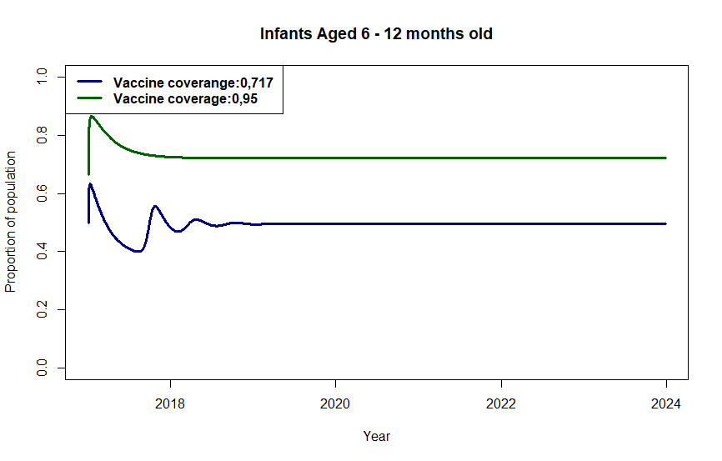

Figure 2: Immunity profiles of the population for infants aged 6 – 12 months.

In Figure 2, the immune profile for the total population of age group 1 is shown. With sustained effort on measles vaccination programmes, after the introduction of the first dose of vaccination with vaccine coverage of 71.1% in infants at 6 – 12 months, the fraction of population that are protected by vaccination has slowly decreased during the year 2017. In the beginning of 2017, it is estimated that 63% of infants were protected by the first dose of vaccination, the proportion of population that is protected by vaccination declined to 40% towards the end of year 2017. Three measles outbreaks occurred in South Africa in 2017, most of these outbreaks occurred in unvaccinated or low vaccination coverage population. Infants at 6 to 12 who received the first dose of vaccination are not successfully protected against measles infection, measles vaccine required two doses of vaccination to be successfully protected against measles infection. Therefore, means they can still contract the measles infection when they are exposed to the virus.

In 2018, after the measles outbreak occurred the fraction of the population that is protected by vaccination begin to increase, it is estimated that it increased by 15%. South Africa has not experienced the measles outbreak since 2017 and the vaccine coverage for the first dose has been stable to 71.7%, this caused the proportion of population that is protected by vaccination to remain stable 50% from 2019 to 2022.

The World Health Organization, recommended that the two doses of measles vaccination should be increased in order to eliminate measles. We explored scenario in which the vaccine coverage of the first dose is increased to 95%. The results are shown in figure 2. Our results show that the proportion of the population that is protected by the vaccine would increase by 20% compared to the current vaccination coverage of 71.1%.

Additionally, the model enables us to project the proportion of population that is protected by the vaccine beyond year 2022. As shown in figure 2, proportion of population that is protected by the vaccine with 71.7% of vaccine coverage will remain 50% by the end of 2024, while the proportion of population that is protected by the vaccine with 95% of vaccine coverage will remain 20% higher. Our future prediction shows that the current vaccine coverage of the first dose vaccine should be increased to 95% to have greater effect on increasing the proportion of population that is protected by vaccine.

The results in figure 3 shows measles immune profiles for the population of age group 2 (1 – 5 years).

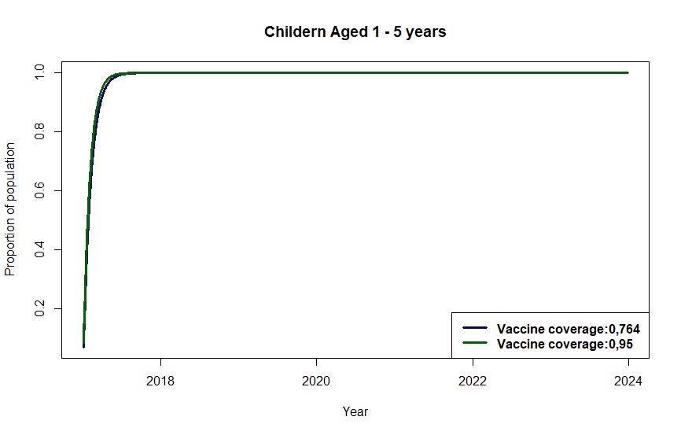

Figure 3: Immunity profiles of the population children aged 1 – 5 years.

In Figure 3, the immune profile for the total population of age group 2 is shown. After the introduction of the second dose of vaccination with vaccine coverage of 76.4% in children at 1 – 5 years, the fraction of population that are protected by vaccination has been increasing from 2017 to 2022. Children receive their second dose of vaccination. After receiving the second dose of vaccination it implies that children are successfully protected against measles infection. Therefore, means they will contract measles infection again even if they are exposed to the virus.

During the measles outbreak in 2017, children at 1 – 5 years that are successfully protected against the measles infection were not affected by measles outbreak. In 2017, the fraction of the population that is protected by vaccination begin to increase, it is estimated that it increased and reach approximately 99%. From 2018 the vaccine coverage for the second dose of vaccination has been stable to 76.4%, this caused the proportion of population that is protected by vaccination to remain stable 99% from 2018 to 2022.

We explored scenario in which the vaccine coverage of the second dose is increased to 95%. The results are shown in figure 3. Our results show that the proportion of the population that is protected by the vaccine would increase to 99% which has result compared to the current vaccination coverage of 76.4%.

Our model allows us to predict the proportion of population that is protected by the vaccine beyond year 2022. As shown in figure 3, proportion of population that is protected by the vaccine with 76.4% of vaccine coverage will remain 99% by the end of 2024, while the proportion of population that is protected by the vaccine with 95% of vaccine coverage will also remain at 99%2. Our future prediction shows that the current vaccine coverage of the second dose vaccine has great effect in fraction of population that is protected by the virus.

## Effect of improving vaccination coverage of measles

The results in figure 4, shows the effect of improving vaccination coverage of measles for the population of age group 1 (6 – 12 months).

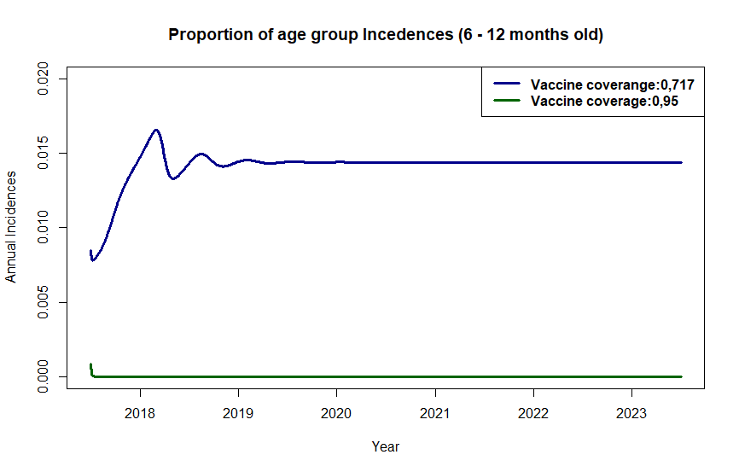

Figure 4: Proportion of measles incidence from age groups 1 under two different sets of vaccination coverage.

In Figure 2 and 3, we contrasted the two possibilities of increasing the vaccine coverage of the first dose and second dose measles vaccine starting in 2016 while maintaining the efficacies of the vaccines as listed in Table 1. The results show that a 95% of vaccine coverage $(θ_{1})$ can increase the fraction of population that is protected by vaccine by approximately 20%. 76.4% and 95% of vaccine coverage $(θ_{2})$ increases the fraction of population that is protected by vaccine to 99%.

In figure 4, the results show that the proportion of annual measles incidences from 2017 to 2018 increases in a case where vaccine coverage is 71.7% for age group 1. Initially, the proportion of annual measles incidences occurred in 2017 is estimated as 0.8%. During the measles outbreak in 2017, the proportion of annual incidences increased to 2%. In the end of 2018, the proportion of annual measles incidences declined to 1.3%. The vaccine coverage of the first dose has been stable to 71.1%, this caused the small proportion of annual measles incidences of 1.5% from 2019 to 2022.

We explored scenario in which the vaccine coverage of the first dose is increased to 95%. The results are shown in figure 4. Our results show that the proportion of annual measles incidences will decline from a small fraction to zero and remains constant in zero. Our model projects the proportion of annual measles incidences beyond year 2022. As shown in figure 4, the proportion of annual measles incidences with vaccine coverage of 71.7% will be constant at 1.5% by the end of 2024, while the proportion of annual measles incidences with vaccine coverage of 95% with be constant at 0%.

The results in figure 4, shows the effect of improving vaccination coverage of measles for the population of age group 1 (6 – 12 months).

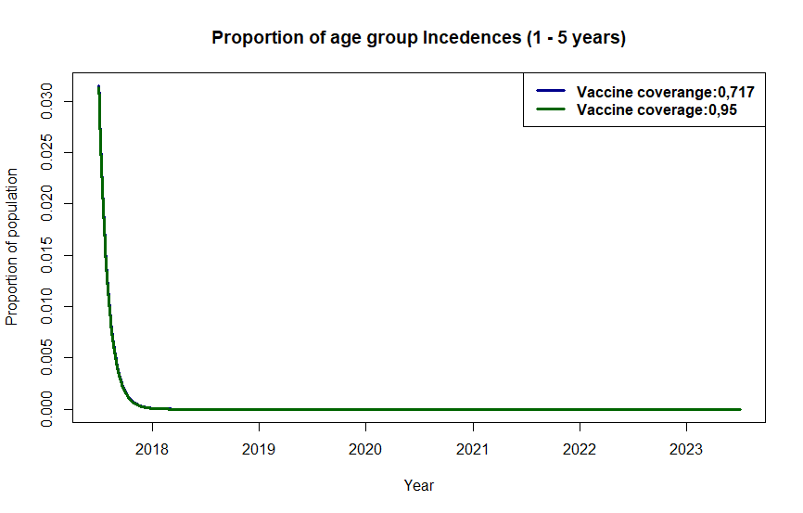

Figure 5: Proportion of measles incidence from age groups 2 under two different sets of vaccination coverage.

In figure 5, the results show that the proportion of annual measles incidences from 2017 to 2018 decrease drastically in a case where vaccine coverage is 76.4% for age group 2. Initially, the proportion of annual measles incidences occurred in 2017 is estimated to be approximately 3%. From 2017 to 2018, the proportion of annual incidences declined to approximately 0.1%. In 2018, the proportion of annual measles incidences declined and reaches 0%. The vaccine coverage of the second dose has been stable to 76.4%, this caused the small proportion of annual measles incidences that is approximately 0% from 2018 to 2022.

We explored scenario in which the vaccine coverage of the first dose is increased to 95%. The results are shown in figure 4. Our results show that the proportion of annual measles incidences are the same as proportion of annual measles incidences with vaccine coverage of 76.4%.

The advantageous effects of the current vaccination programme in South Africa, our model projection shows that the annual measles incidences will remain lower than the World Health Organization elimination goal of 5 cases per one million population. From the immune profile analysis, we can observe that a contributing factor is the low effective coverage of vaccine coverage $(θ_{1})$ among infants ages 6 to 12 months, which will only be at 50% by the end of 2024. Between 2017 and 2018, this age group experienced the highest incidence of measles in figure 4. By either boosting effective coverage $(θ_{1}σ_{1})$, the vaccine coverage rate of vaccine coverage can be raised.

# Conclusion

# References

1. Perry, R.T. and Halsey, N.A., 2004. The clinical significance of measles: a review. *The Journal of infectious diseases*, *189* (Supplement_1), pp.S4-S16.
2. Goldfarb, J., 2019. Measles: A dangerous vaccine-preventable disease returns. *Cleveland Clinic Journal of Medicine*, *86*(6), p.393.
3. WHO Joint News Release. More than 140,000 die from measles as cases surge worldwide. 2019. Available at: <https://www.who.int/news-room/detail/05-12-2019-more-than-140-000-die-from-measles-as-cases-surge-worldwide>
4. Hamborsky J, Kroger A, Wolfe S, eds. 13th ed. Washington D.C. Public Health Foundation. 2015.Centers for Disease Control and Prevention. Measles. *Epidemiology and Prevention of Vaccine-Preventable Diseases*.
5. Battegay, R., Itin, C. and Itin, P., 2012. *Dermatological signs and symptoms of measles: a prospective case series and comparison with the literature*. Dermatology, 224(1), pp.1-
6. Coale, A.J., 1957, January. How the age distribution of a human population is determined. In *Cold spring harbor symposia on quantitative biology* (Vol. 22, pp. 83-89). Cold Spring Harbor Laboratory Press.
7. Zhang, Z., Qiao, X., Yang, S. and Jiang, X., 2018. *Non-uniform distribution of contamination on composite insulators in HVDC transmission lines*. Applied Sciences, *8*(10), p.1962.
8. Battegay, R., Itin, C. and Itin, P., 2012. *Dermatological signs and symptoms of measles: a prospective case series and comparison with the literature*. Dermatology, 224(1), pp.1-
9. WHO Joint News Release. More than 140,000 die from measles as cases surge worldwide. 2019. Available at: <https://www.who.int/news-room/detail/05-12-2019-more-than-140-000-die-from-measles-as-cases-surge-worldwide>
10. Moss, W.J. and Griffin, D.E., 2006. Global measles elimination. *Nature Reviews Microbiology,* 4(12), pp.900-908.
11. Strebel, P.M., Papania, M.J., Fiebelkorn, A.P., Halsey, N.A., Plotkin, S., Orenstein, W. and Offit, P., 2012. *Measles vaccine. Vaccines*, *6*, pp.352-387.
12. Madhi SA, Rees H. Special focus on challenges and opportunities for the development and use of vaccines in Africa. *Human Vaccines & Immunotherapeutics. 2018;14*(10):2335-9.
13. WHO Africa. Experts caution against stagnation of immunization coverage in Africa.

2019. Available at: <https://www.afro.who.int/news/experts-caution-against-stagnationimmunization-coverage-africa>

1. Cutts, F.T. and Markowitz, L.E., 1994. *Successes and failures in measles control.* Journal of infectious diseases, 170(Supplement_1), pp.S32-S41.
2. Gautret, P., Botelho‐Nevers, E., Brouqui, P. and Parola, P., 2012. The spread of vaccine‐preventable diseases by international travellers: a public‐health concern. *Clinical Microbiology and Infection*, *18*, pp.77-84.
3. World Health Organization. Available at: <https://www.who.int/news-room/fact-sheets/detail/measles>
4. Marelli, A.J., Mackie, A.S., Ionescu-Ittu, R., Rahme, E. and Pilote, L., 2007. Congenital heart disease in the general population: changing prevalence and age distribution. Circulation, 115(2), pp.163-172.
5. Zhang, Z., Qiao, X., Yang, S. and Jiang, X., 2018. Non-uniform distribution of contamination on composite insulators in HVDC transmission lines. *Applied Sciences*, *8*(10), p.1962.
6. Statistics South Africa. 2021. *South Africa: Age structure from 2011 to 2021*. Available at: <https://www.statista.com/statistics/578938/age-structure-in-south-africa/>
7. South Africa Government. 2021. Available at: <https://www.gov.za/about-sa/people-south-africa>
8. Mossong, J., Hens, N., Jit, M., Beutels, P., Auranen, K., Mikolajczyk, R., Massari, M., Salmaso, S., Tomba, G.S., Wallinga, J. and Heijne, J., 2008. Social contacts and mixing patterns relevant to the spread of infectious diseases. PLoS medicine, 5(3), p.e74.